**Lab 1**

**Diagram:**

Before Simulation

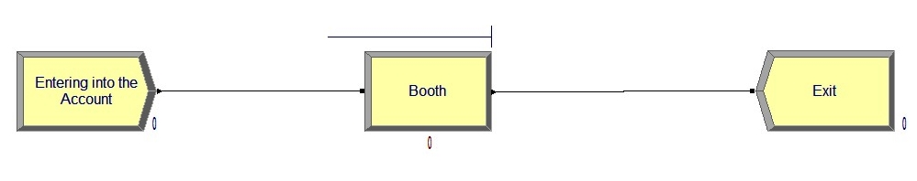

After Simulation

